Normal data ETL system

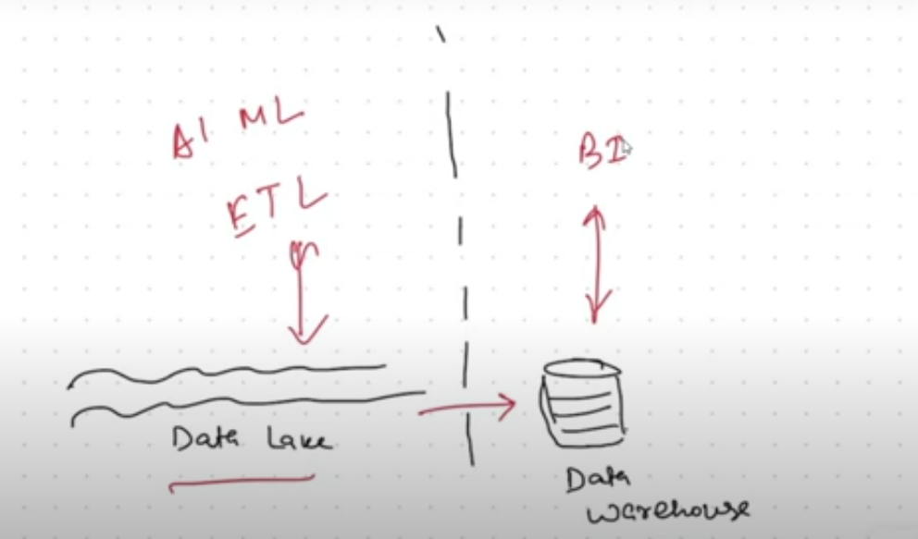s

In general we use Data lake is for ETL jobs or data processing and Data warehouse is to reporting purpose.

And when we want data in data warehouse, we push our data in data warehouse from data lake.

So, post pushing the data into data warehouse from data lake, there will be 2 copies of the data at 2 locations having different owners.

But in databricks, we have combinations of both data lake and data warehouse = Data lakehouse.

Now we can keep our data in our data lake in open formats – parquet, CSV etc and then we can have a engine called **delta lake**, which will basically communicate with your data lake and it improves the reliability, security and performance of data lakes.

***Delta Lake*** is an open-source storage layer in Databricks that improves the reliability, security, and performance of data lakes:

***Transaction log***: Delta Lake adds a file-based transaction log to Parquet data files, which allows for ACID transactions, data versioning, and rollback capabilities.

***Unified data handling***: Delta Lake allows you to handle both batch and streaming data in a unified way.

***Table abstraction***: Delta tables are built on top of the storage layer, making it easy to work with large-scale structured data using SQL and the DataFrame API.

***Performance***: Data loads and queries can run up to 1.7x faster than other storage formats.

***AI-driven enhancements:*** Delta Lake automatically administers, configures, and tunes data.

***Security and governance:*** Delta Lake provides fine-grained access controls for data governance.

Delta Lake can be used on top of data stored in cloud storage, such as AWS S3, Azure Storage, and GCS.

Now you don’t need to move your data out of your data lake. In Databricks same data can serve the purpose of ETL processing along with the warehouse purpose to publish report in BI tools.

****Data lake****

A centralized repository that stores, ingests, and processes large amounts of data in its original form. Data lakes can store relational and non-relational data, and can be used for data science and machine learning.

**Delta Lake**

An open-source storage layer that runs on top of an existing data lake. Delta Lakes add features to improve data reliability, security, and performance, such as:

* ACID transactions
* Schema enforcement
* Lineage tracking
* Data versioning and time travel
* Scalable metadata
* Unified streaming and batch data processing

Delta Lakes are often used with data lakes to create a more robust and reliable data storage solution.

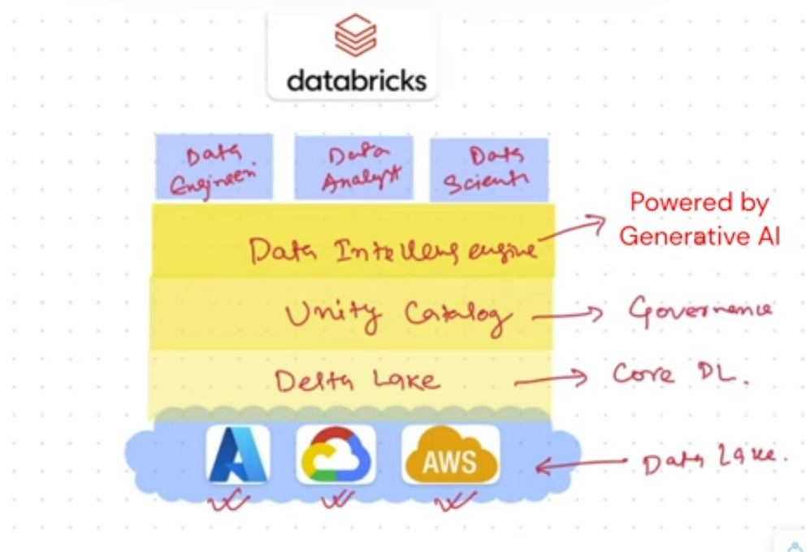J

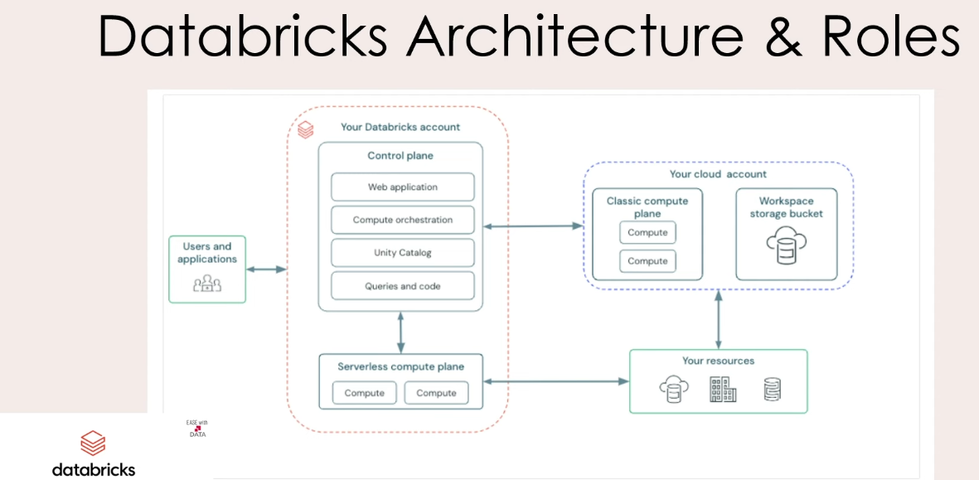

## High-level architecture

Databricks operates out of a ****control plane**** and a ****compute plane****.

* The ****control plane**** includes the back-end services that Databricks manages in your Databricks account. The web application is in the control plane.
* The ****compute plane**** is where your data is processed. There are two types of compute planes depending on the compute that you are using.
* For server-less compute, the server-less compute resources run in a server-less compute plane in your databricks account.
* For classic Databricks compute, the compute resources are in your AWS account in what is called the classic compute plane. This refers to the network in your AWS account and its resources.

To learn more about classic compute and server-less compute, see [Types of compute](https://docs.databricks.com/en/compute/index.html" \l "types-of-compute).

Each Databricks workspace has an associated storage bucket known as the ****workspace storage bucket****. The workspace storage bucket is in your AWS account.

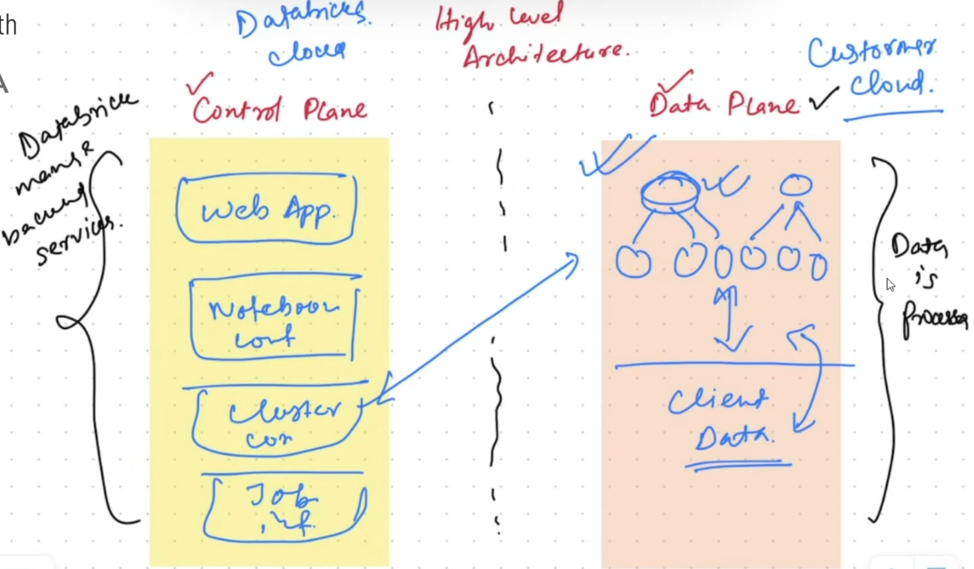

Cluster which we create to process the data, got created on client customer account.

Now these clusters will be managed from cluster configurations by control plane, and this cluster would run in the data plane in order to process the client data and saves the data back at the client cloud account. So there will not be any data movement but configuration and access would be managed through the control plane.

Roles at databricks:

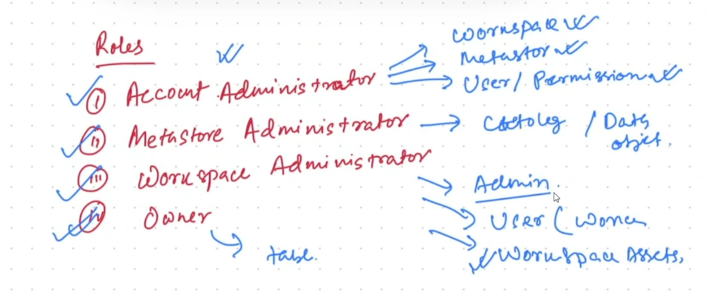

a

**Unity catalog**

https://docs.databricks.com/en/data-governance/unity-catalog/index.html

Unity Catalog, a unified governance(secure,available and accurate) solution for data and AI assets on Databricks.

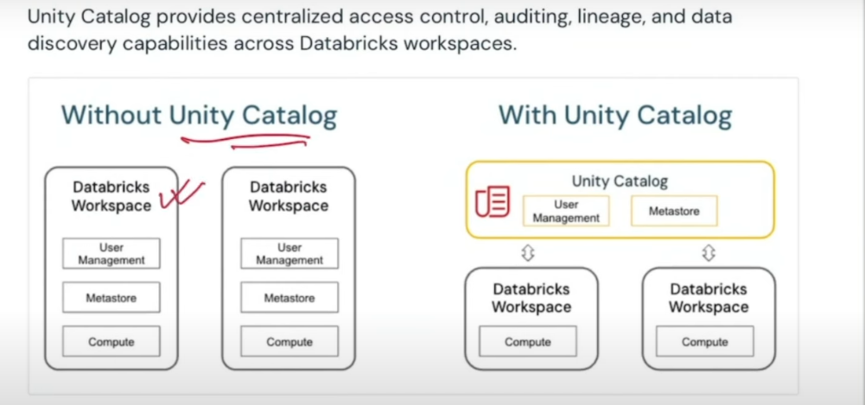It’s an open source provides security,lineage,data discovery.

Object model of unity catalog:

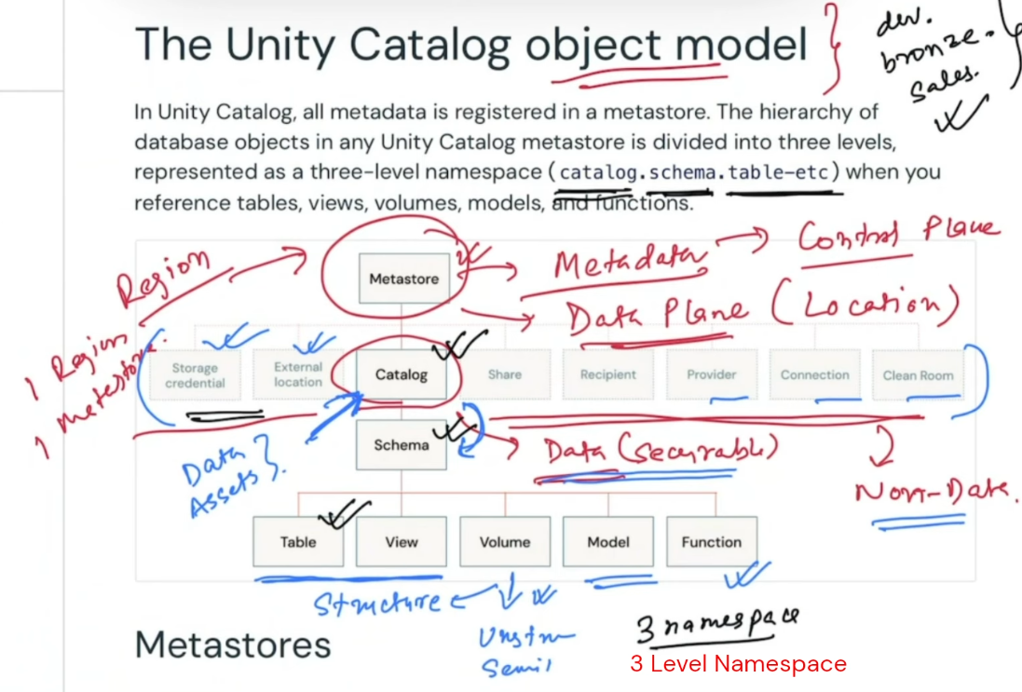

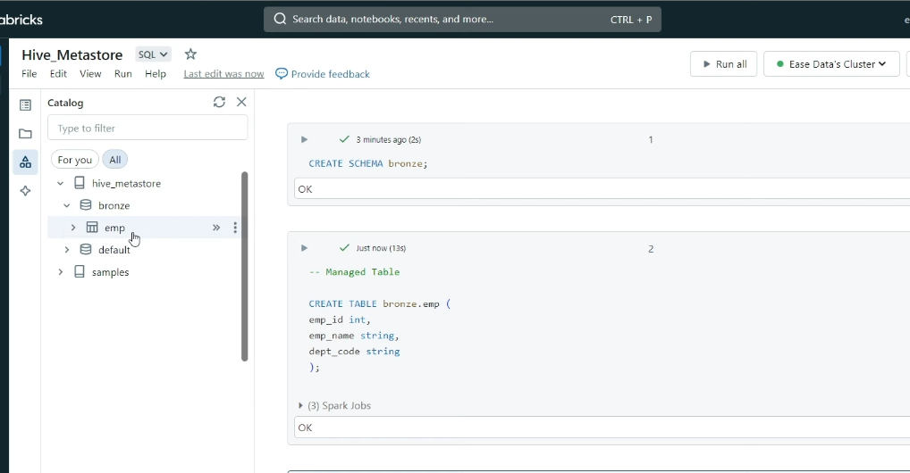

Below command is to check the data files of any particular table:

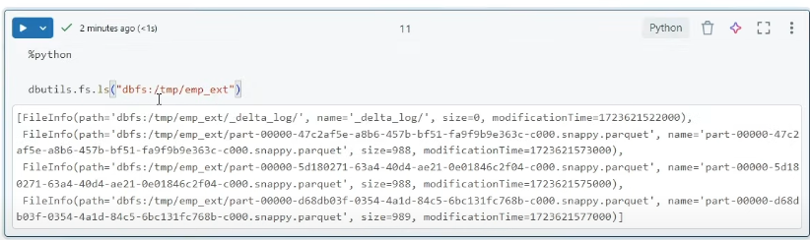

top level container is metastore: below is account console screenshot to create the metastore.

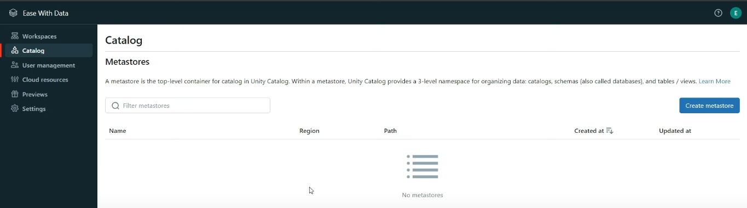

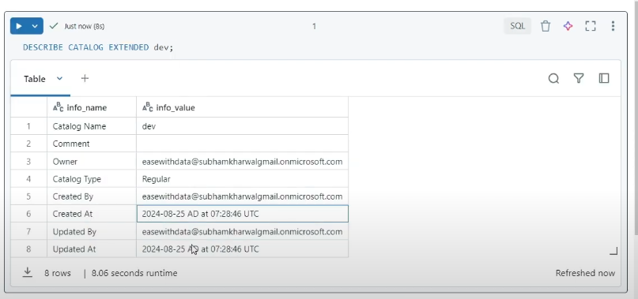

Command to delete the catalog in databricks:

if we want to delete any catalog, we will have to delete all the schemas and table which are created in it.

Or we can delete it using cascade parameter.

DROP CATALOG <catalog name> CASCADE

To create catalog with external location for managed table:

First we will have to create the external location in databricks:

Go to the catalog tab and the external data on top, then click location.

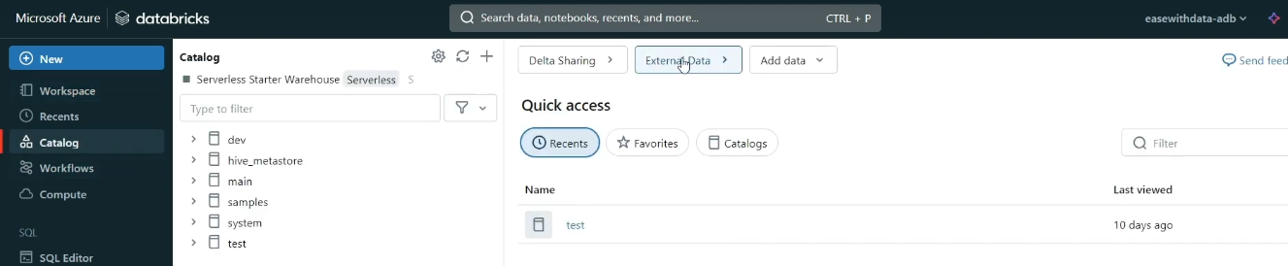

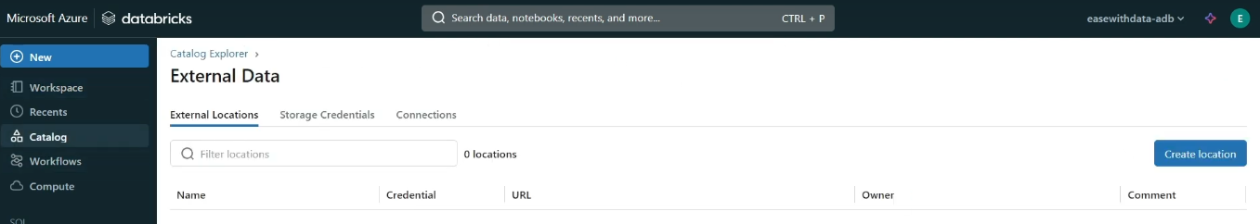

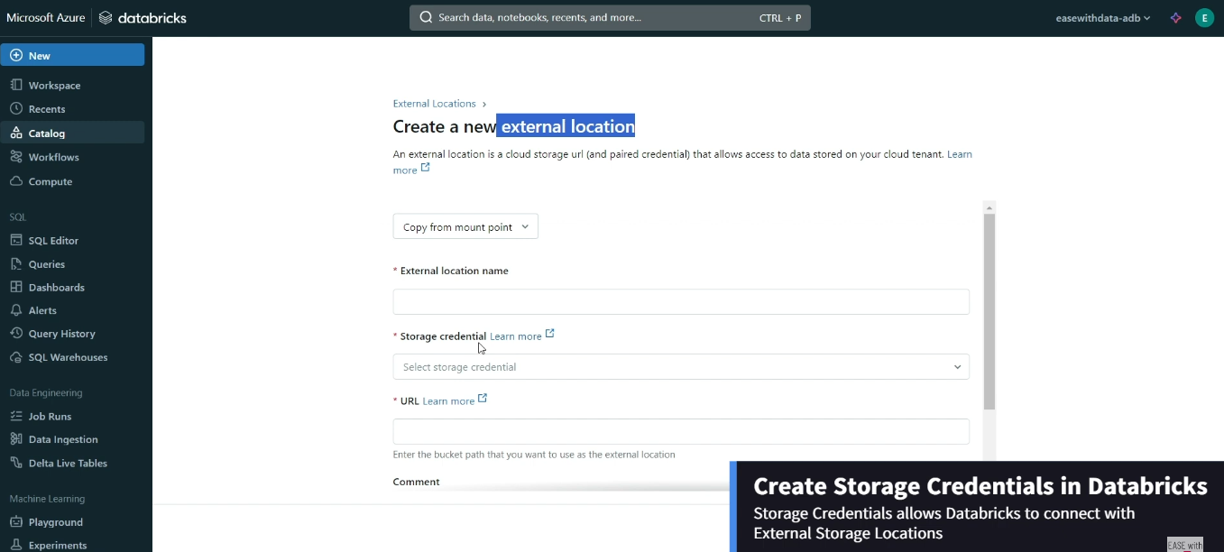

Below SQL command to create external location:

CREATE EXTERNAL LOCATION [IF NOT EXISTS] location_name

URL url_str

WITH (STORAGE CREDENTIAL credential_name)

[COMMENT comment]

Example below:

-- Create a location accessed using the s3_remote_cred credential

> **CREATE** **EXTERNAL** **LOCATION** s3_remote URL 's3://us-east-1/location'

**WITH** (**STORAGE** CREDENTIAL s3_remote_cred)

**COMMENT** 'Default source for AWS exernal data';

External location can be created for managed table or external table both.

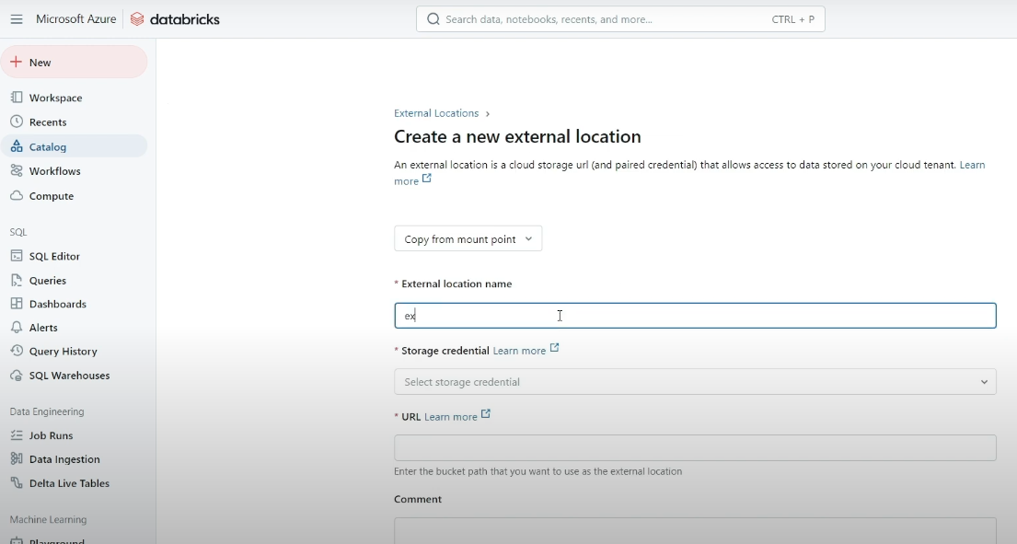D

Main difference between unity catalog and legacy hive metastore

even after the deletion of managed table, data files remain in the external location for 7 to 30 days, which gives user to get the table back in unity catalog. But in hive metastore, once managed table gets deleted then data will also be deleted.

_________________________________________________________________________________

How to see the deleted table:

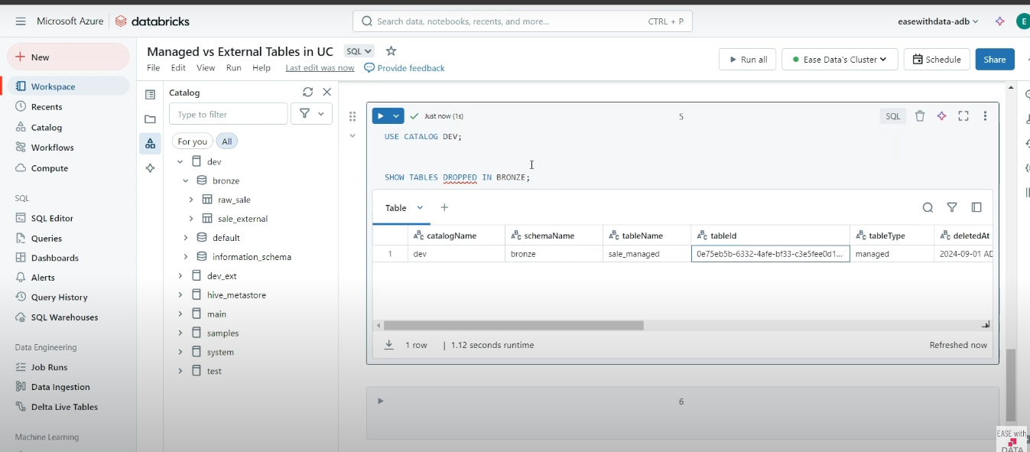

and using undrop command we can undrop a table.

Command to check particular catalog exist or not.

Show catalog like ‘dev*’

Show schemas in dev like ‘text’ – this is to check schema in dev catalog

Above command will give catalog results which starts with dev

command to check whether table exist or not:

spark.catalog.tableExists(“dev.bronze.sale_external”)

In databricks we can see the history of delta tables:

describe history dev.bronze.emp;

Temporary views vs permanent views

Temporary views get deleted once session gets deleted.

Deep clone vs shallow clone in delta table:

Deep clone – It will copy all meta data and data(latest version) .

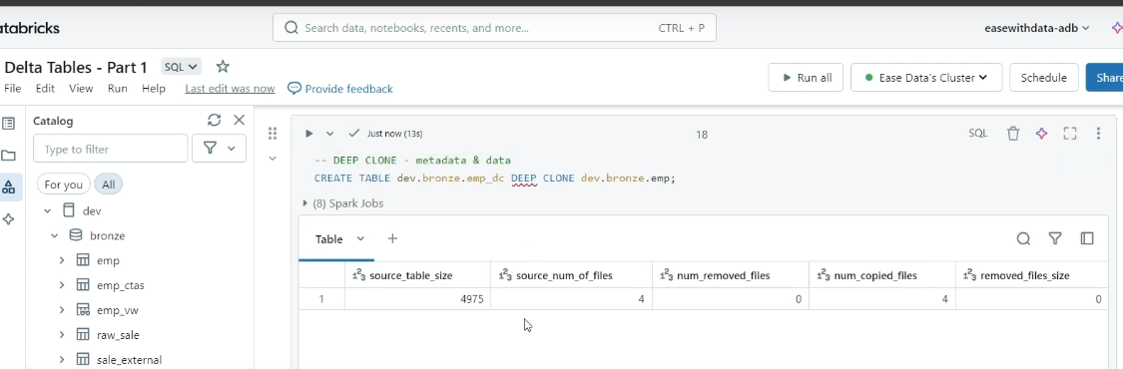

Shallow clone – It will only copy meta data and data will still point to the main table from where we ran shallow clone commands.

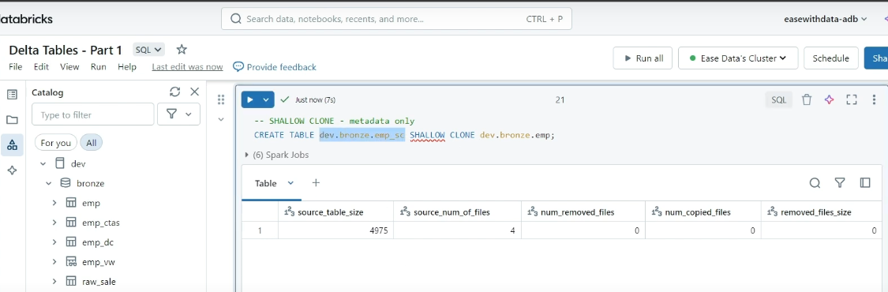

Even if we update the main table using which we created the shallow table, there won’t be any impact on shallow table post update. As it will only fetch data from specific version.

**Merge/Upsert operation on delta tables:**

When keys between source and target table matches, then do update and if doesn’t matches, then insert.

Third condition(last one in below screenshot), when we have extra keys at target table which are not available at source table, In that scenario, we can take extra decision like either mark them inactive(last one in below screenshot) or delete them.

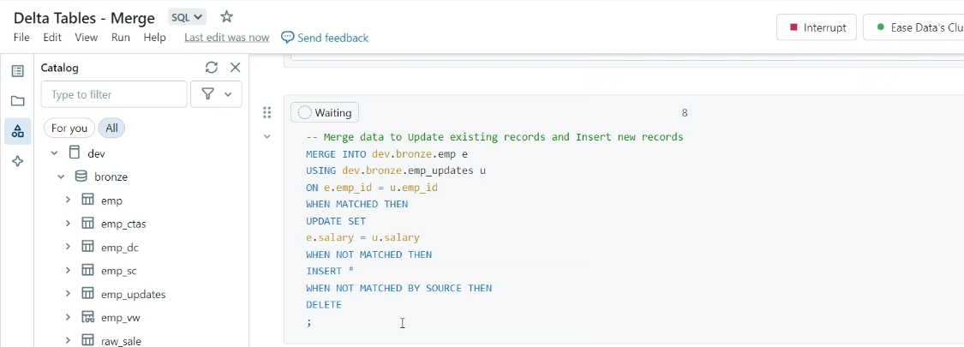

When we want to mark inactive on extra target records which doesn’t match with source, then first we need to create a new column as “is_active” and mark all records as Y.

and write statement in your merge statement like:

WHEN NOT MATCHED BY SOURCE

THEN UPDATE SET

IS_ACTIVE = ‘N’;

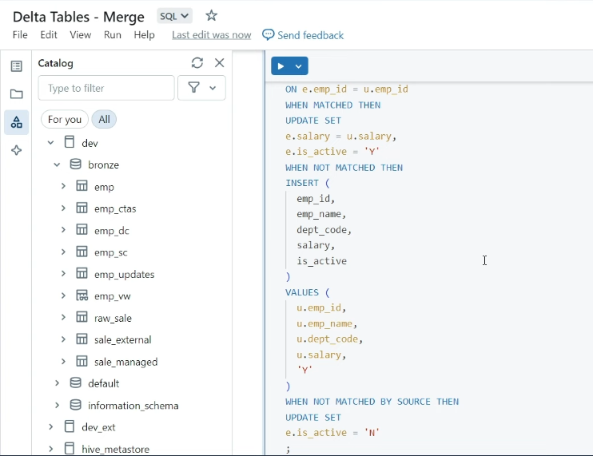

Deletion vectors:

Deletion vectors are a storage optimization feature that can be enabled on Delta Lake tables. By default, when a single row in a data file is deleted, the entire Parquet file containing the record must be rewritten. With deletion vectors enabled for the table, some Delta operations use deletion vectors to mark existing rows as removed without rewriting the Parquet file. Subsequent reads on the table resolve current table state by applying the deletions noted by deletion vectors to the most recent table version.

Support for deletion vectors was incrementally added with each Delta Lake version. The table below depicts the supported operations for each Delta Lake version.

In simple explanation:

When we do any modification in data, even a single row, then whole parque file will be re-written.

**Problem:**

Let say, our data is of billions of records, and we just updated single record, and then again whole parquet file will be re-written. And thats a optimization issue.

**Solution:**

Add delta vectors. So if we have a scenario like above, when only single record got updated, and delta vectors are enabled.

Then that deleted row will be flagged as deleted in the parquet file.

So, next time when we read the data from that particular parquet file, only the rows which are not marked/flagged as deleted will be read.

And next time, when we run optimization/predictive maintenance, automatically our parquet file will be re-written and all the rows which are marked/flagged as deleted will be removed.

**Apply changes to Parquet data files**

Deletion vectors indicate changes to rows as soft-deletes that logically modify existing Parquet data files in the Delta Lake tables. These changes are applied physically when data files are rewritten, as triggered by one of the following events:

* A DML command with deletion vectors disabled (by a command flag or a table property) is run on the table.
* An OPTIMIZE command is run on the table.
* REORG TABLE ... APPLY (PURGE) is run against the table.

UPDATE, MERGE, and OPTIMIZE do not have strict guarantees for resolving changes recorded in deletion vectors, and some changes recorded in deletion vectors might not be applied if target data files contain no updated records, or would not otherwise be candidates for file compaction.

**REORG TABLE ... APPLY (PURGE) rewrites all data files containing records with modifications recorded using deletion vectors.**

**Apply changes with REORG TABLE**

Reorganize a Delta Lake table by rewriting files to purge soft-deleted data, such as rows marked as deleted by deletion vectors with REORG TABLE:

REORG **TABLE** events APPLY (PURGE);

-- If you have a large amount of data and only want to purge a subset of it, you can specify an optional partition predicate using `WHERE`:

REORG **TABLE** events **WHERE** date >= '2022-01-01' APPLY (PURGE);

REORG **TABLE** events

**WHERE** date >= **current_timestamp**() - INTERVAL '1' **DAY**

APPLY (PURGE);

Note

* REORG TABLE only rewrites files that contain soft-deleted data.
* When resulting files of the purge are small, REORG TABLE will coalesce them into larger ones. See [OPTIMIZE](https://docs.delta.io/optimizations-oss.html) for more info.
* REORG TABLE is idempotent, meaning that if it is run twice on the same dataset, the second run has no effect.
* After running REORG TABLE, the soft-deleted data may still exist in the old files. You can run [VACUUM](https://docs.delta.io/latest/delta-utility.html" \l "-delta-vacuum) to physically delete the old files.

**Command to enable deletion vectors:**

**ALTER** **TABLE** <**table_name**> **SET** TBLPROPERTIES ('delta.enableDeletionVectors' = **true**);

**Warning**

When you enable deletion vectors, the table protocol version is upgraded. After upgrading, the table will not be readable by Delta Lake clients that do not support deletion vectors. See [How does Delta Lake manage feature compatibility?](https://docs.delta.io/latest/versioning.html).

In Delta Lake 3.0 and above, you can drop the deletion vectors table feature to enable compatibility with other Delta clients.

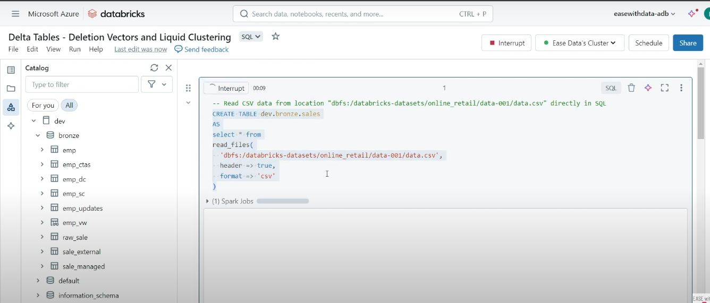

**Now lets delete a row on deletion vector enabled table:**

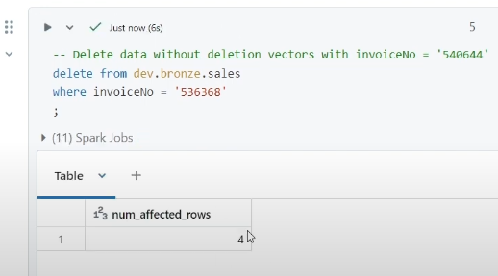

**Now lets check whether record got deleted or deletion vector worked as flagged.**

Using command:

describe history dev.bronze.sales;

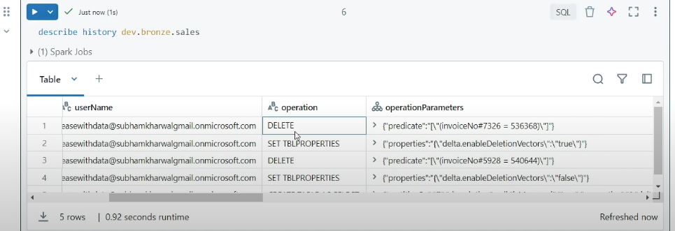

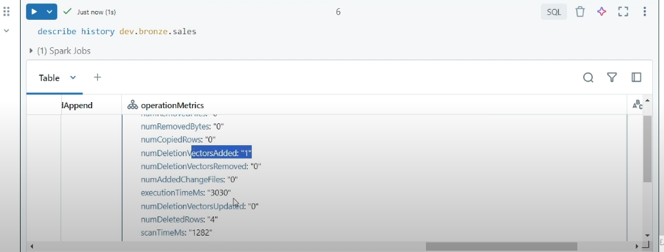

We can see in above screenshot, that post deletion, deletion vector added as 1 for 4 deleted rows.

Data is not re-written in this case, rather it has added those 4 records to the deletion vector.

**Partitioning** :

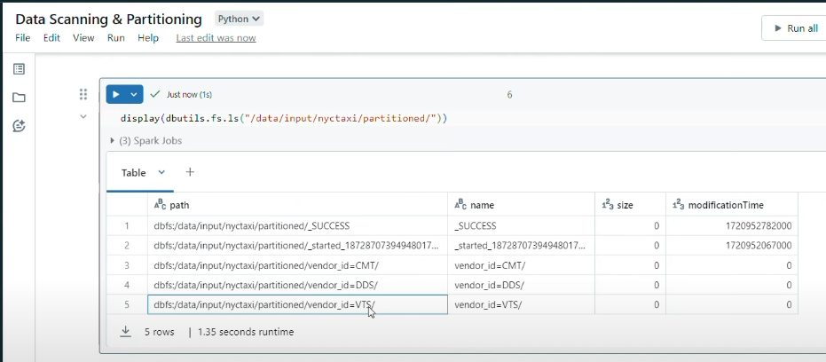

**Data skipping/avoiding unnecessary data or z-ordering in delta lake tables:**

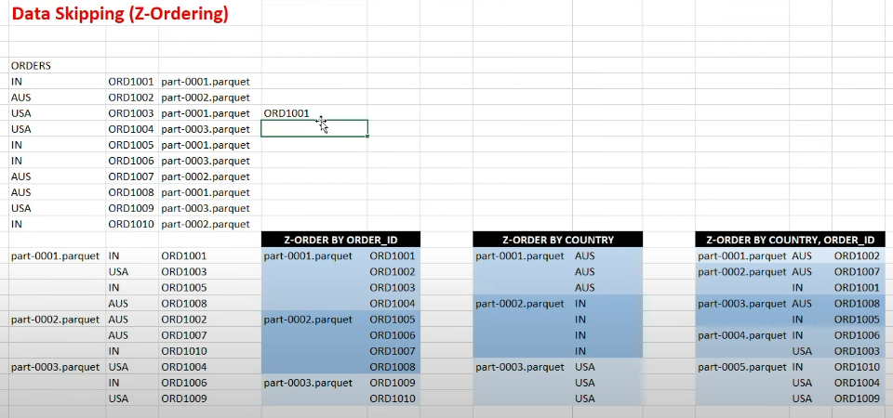

When we have data with high cardinality(orderId) like above example, and getting lots of partitions in table, in that case, delta lake implement z-ordering to resolve this issues.

Because, let say, we need to fetch orderId ORD1001, which is part-0001.parquet file, but while reading, it will scan data from all of the files.

But if we do Z-Order by Order_ID, it will divide the order_ID into multiple files on the bases of orders(refer above screenshot). And Due to which while reading, data won’t be scanned completely.

Z-ordering can be implemented on multiple fields too(refer above screenshot third example).

**Optimization technique on delta lake tables:**

We can opt for delta optimize max file size. For example let say, we have a data of 1.5 GB, So by default, it will try to make the output file of max 1 GB of 1 file and rest other file will be of 0.5GB.

We can alter this configuration also.

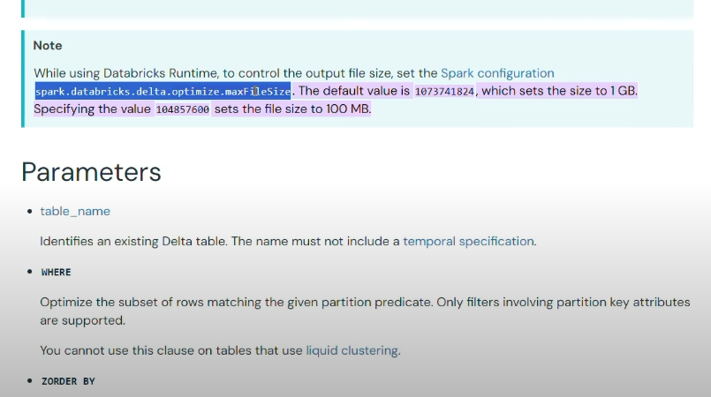

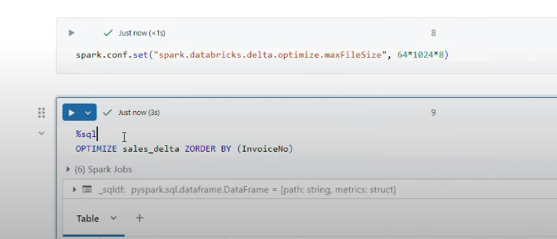

Above data size is in bytes and later using optimize command, we implement the change by implement the zorder by invoiceNo.

So, with above changes our invoceNo data will be in order and then distributed in different part files.

**Another best approach to delta lake tables:**

Implement partitioning along with Z-ordering on table to get the data quickly.

**Use liquid clustering for Delta tables**

Liquid clustering improves the existing partitioning and ZORDERtechniques by simplifying data layout decisions in order to optimize query performance. Liquid clustering provides flexibility to redefine clustering columns without rewriting existing data, allowing data layout to evolve alongside analytic needs over time.

**In simple explanation:**

Earlier problem was, we have to re-write the data whenever we tries to optimize the table.

So, whenever we enable the **liquid clustering** on a particular column in a delta table, you don’t need to re-write the data. Incremental data will automatically get adjusted as per the column that you have mentioned.

**What is liquid clustering used for?**

The following are examples of scenarios that benefit from clustering:

* Tables often filtered by high cardinality columns.
* Tables with significant skew in data distribution.
* Tables that grow quickly and require maintenance and tuning effort.
* Tables with access patterns that change over time.
* Tables where a typical partition column could leave the table with too many or too few partitions.

**Enable liquid clustering**

You must enable liquid clustering when creating a table. Clustering is not compatible with partitioning or ZORDER. Once enabled, run OPTIMIZE jobs as normal to incrementally cluster data. See How to trigger clustering.

To enable liquid clustering, add the CLUSTER BY phrase to a table creation statement, as in the examples below:

Note

In Delta Lake 3.2 and above, you can use DeltaTable API in Python or Scala to enable liquid clustering.

Using SQL:

-- Create an empty table

**CREATE** **TABLE** table1(col0 int, col1 string) **USING** DELTA **CLUSTER** **BY** (col0);

-- Using a CTAS statement

**CREATE** **TABLE** table2 **CLUSTER** **BY** (col0) -- specify clustering after table name, not in subquery

**AS** **SELECT** * **FROM** table1;

Using Python:

# Create an empty table

DeltaTable.create()

.tableName("table1")

.addColumn("col0", dataType = "INT")

.addColumn("col1", dataType = "STRING")

.clusterBy("col0")

.execute()

**Warning**

Tables created with liquid clustering have Clustering and DomainMetadata table features enabled (both writer features) and use Delta writer version 7 and reader version 1. Table protocol versions cannot be downgraded. See [How does Delta Lake manage feature compatibility?](https://docs.delta.io/latest/versioning.html).

**How to trigger clustering**

Use the OPTIMIZE command on your table, as in the following example:

SQL

OPTIMIZE table_name;

Liquid clustering is incremental, meaning that data is only rewritten as necessary to accommodate data that needs to be clustered. Already clustered data files with different clustering columns are not rewritten.

Command to change the clustering column:

**ALTER** **TABLE** **table_name** **CLUSTER** **BY** (new_column1, new_column2);

Command to turn off clustering:

**ALTER** **TABLE** **table_name** **CLUSTER** **BY** **NONE**;

You can use DESCRIBE DETAIL commands to see the clustering columns for a table, as in the following examples:

**DESCRIBE** DETAIL **table_name**;

The following limitations exist:

* You can only specify columns with statistics collected for clustering columns. By default, the first 32 columns in a Delta table have statistics collected.
* You can specify up to 4 clustering columns.

**Important**

In Delta Lake 3.1, users needs to enable the feature flag spark.databricks.delta.clusteredTable.enableClusteringTablePreview to use liquid clustering. The following features are not supported in this preview:

* ZCube based incremental clustering.
* ALTER TABLE ... CLUSTER BY to change clustering columns.
* DESCRIBE DETAIL to inspect the current clustering columns.

In Delta Lake 3.2, the preview flag is removed and the above features are supported.

**Volumes in databricks**

Prerequisite for Volumes are:

* Unity-catalog enabled
* Databricks runtime 13.3 LTS and above

There are 2 types of Volumes:

Managed and External

And to get the External volumes, we need an external location which we have discussed above.

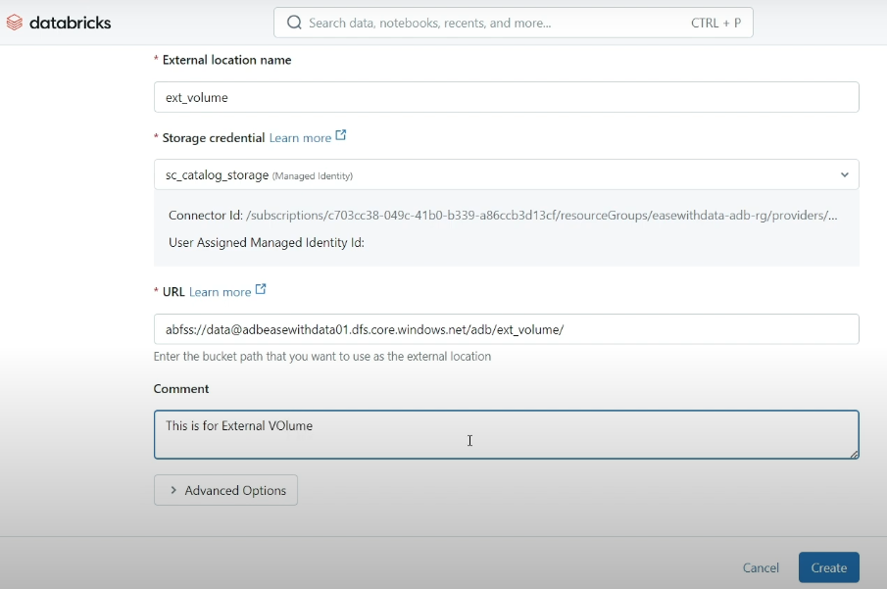

___________________________________________________________________________________

**Managed volume:**

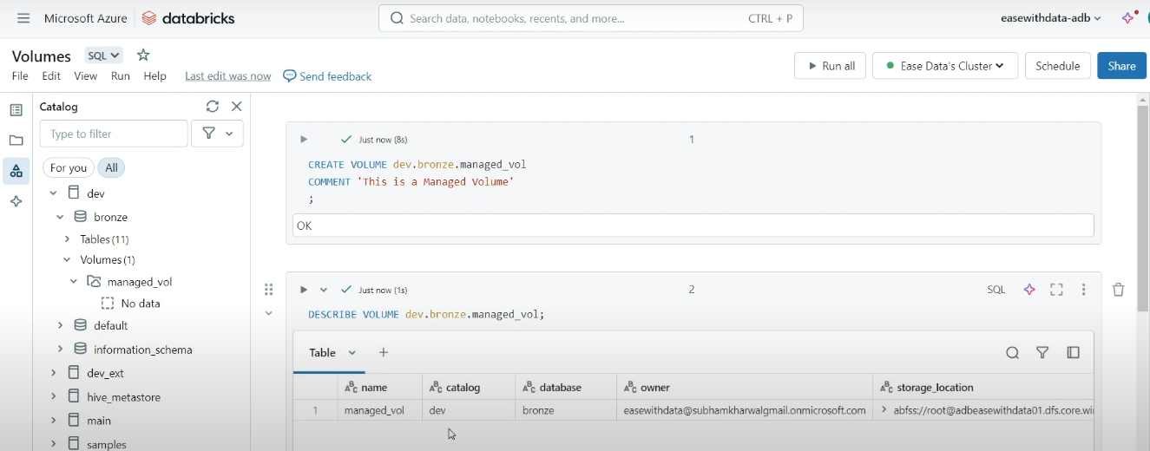__________________________________________________________________________________________

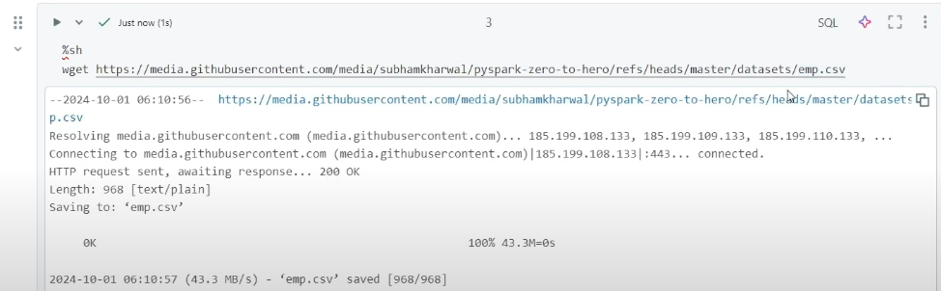We can download any file using wget in databricks using %sh magic command.

__________________________________________________________________________________________

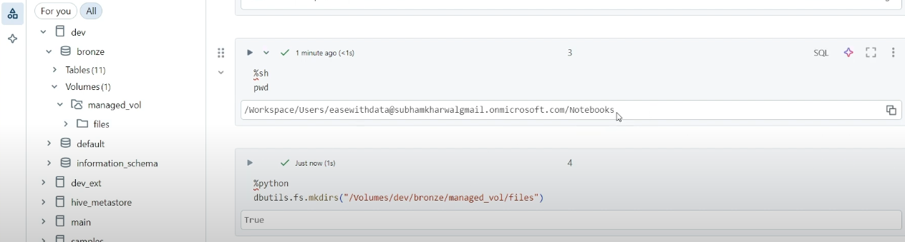Command to create the directory for volumes, we can using dbutils

-- dbutils.fs.mkdirs(“/Volumes/<catalog name>/<schema name>/<volume name>/<directory needs to be created>”)

dbutils.fs.mkdirs(“Volumes/dev/bronze/managed_vol/files”)

__________________________________________________________________________________________

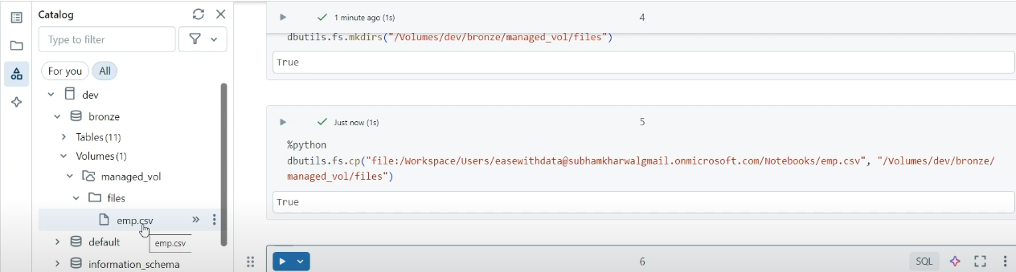dbutils.fs.cp(“[file:/](../../../)<source file location>,<target file location>”) to copy files in databricks.

__________________________________________________________________________________________

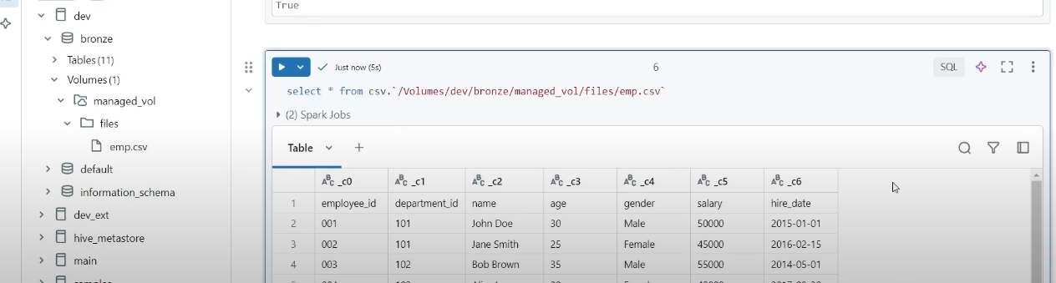We can now directly fetch the data from volume.

**External Volumes:**

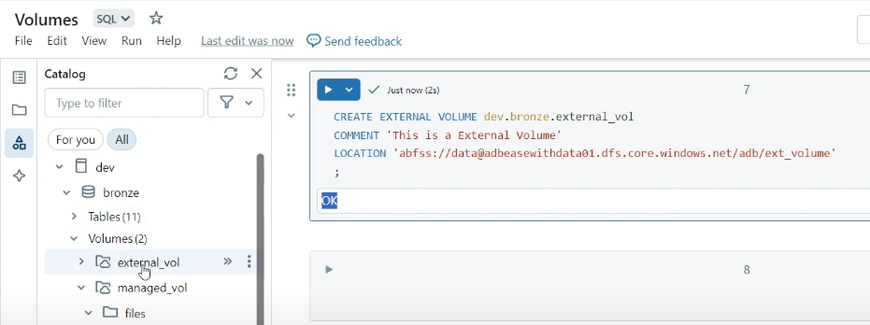

**Difference between managed volume and external volume:**

deletion:

we will have to delete all the tables,schema to delete the managed volume.

But when we delete an External volume, then data will remain in the external location.

Only the metadata of external volume will be deleted.

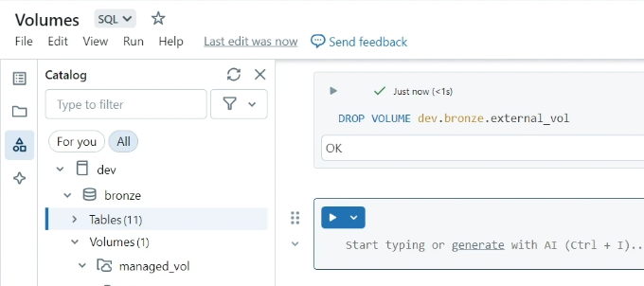

**Databricks utilities(dbutils):**

dbutils.help()

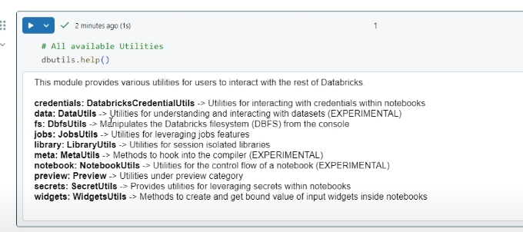dbutils.fs.help()

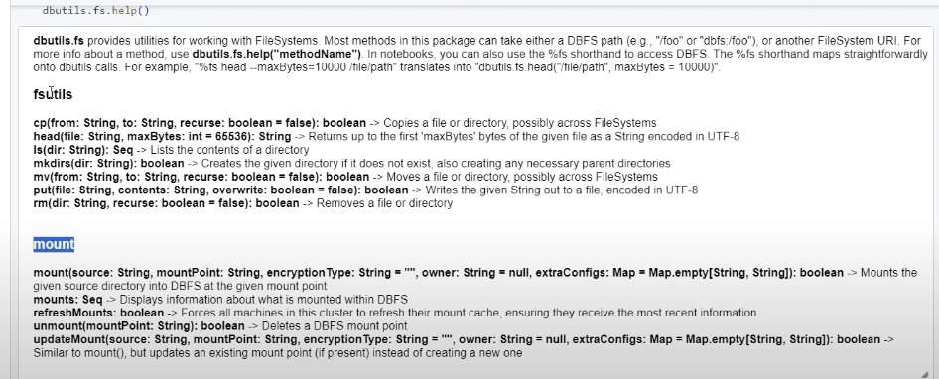

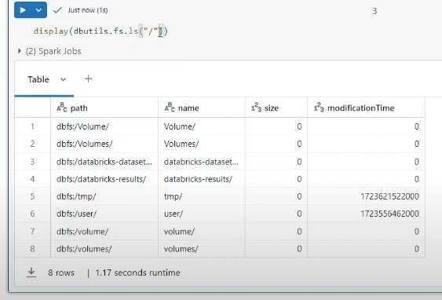

Check the volumes using below command:

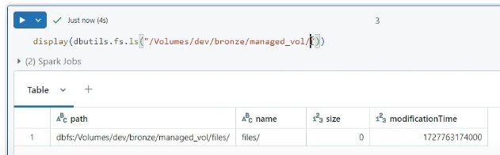d

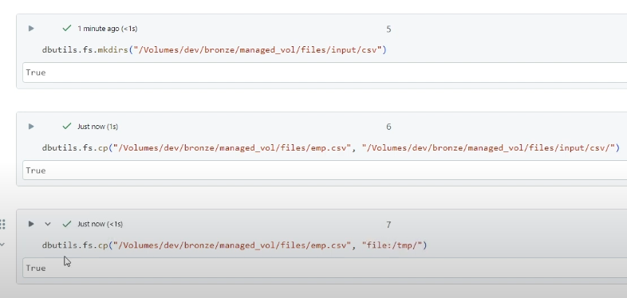x

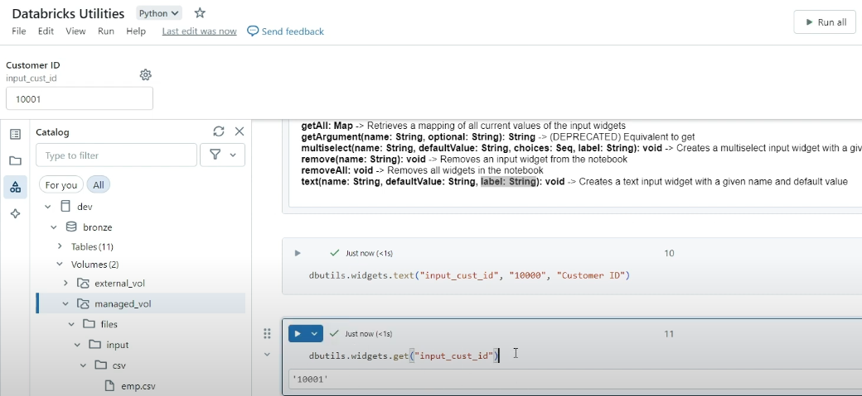_____________________________________________________________________________________

Same above widget we can use in SQL too, refer below screenshot:

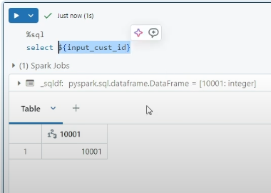

_________________________________________________________________________________________

Below _dept is a variable of a text widget, where value is sales.

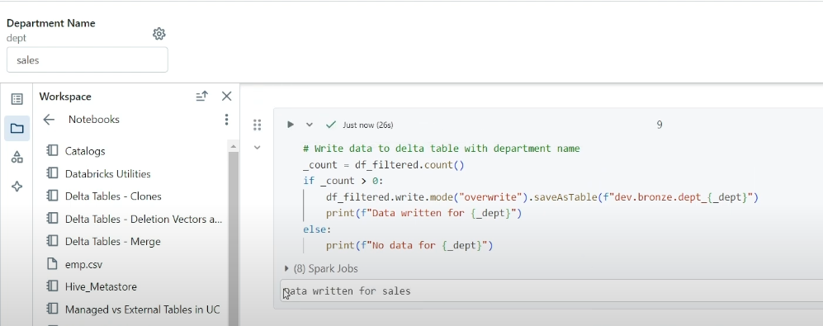

Now, we will pass the count value to other notebook to utilize it further using dbutils.

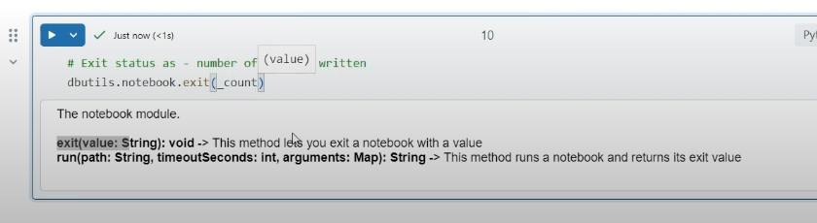_______________________________________________________________________________

So, using dbutils.notebook.run we can run any child notebook by passing the notebook name(refer below screenshot) from parent notebook.

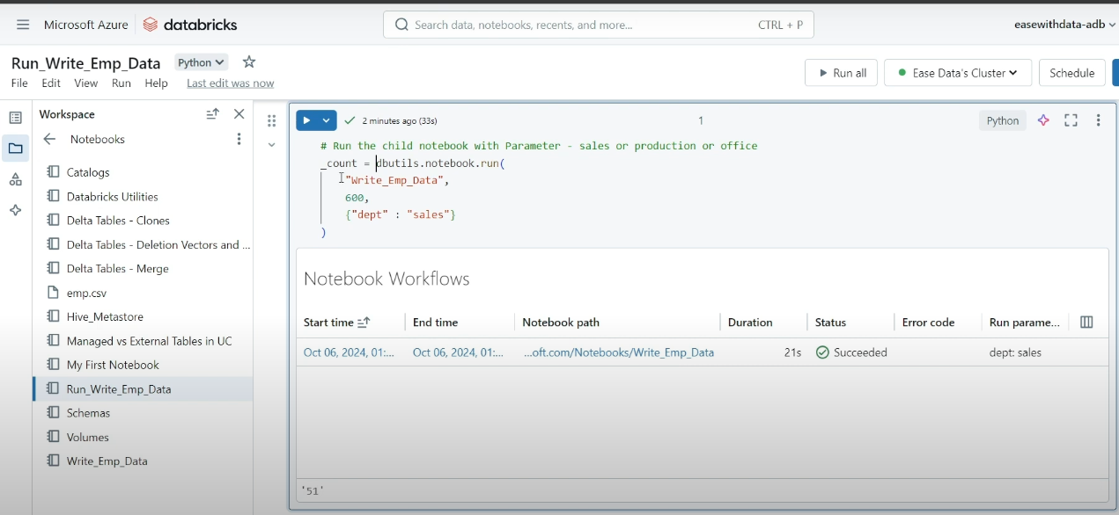

**Workflow in databricks:**

Below is a way to set the value of a variable using dbutils and pass it to another task of a job in databricks:

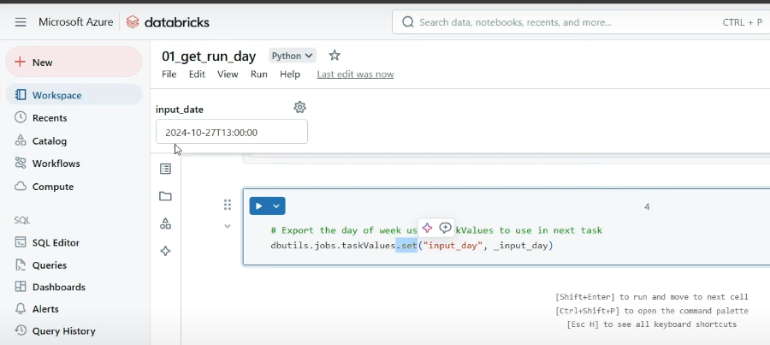________________________________________________________________________________________

Below is the way, we can fetch the value from a notebook task in a different notebook and utilize it further.

Like above input_Day value which we set, we are passing in below notebook task:

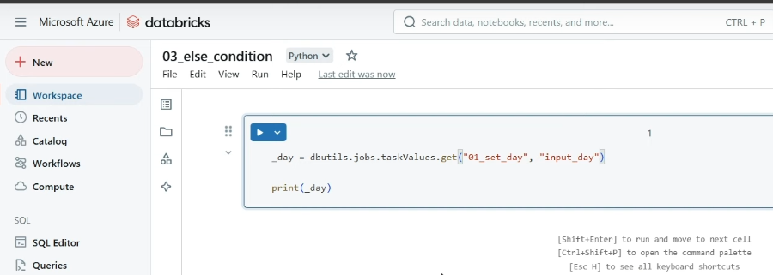

**workflow create job/my existing jobs page(currently no jobs)**:

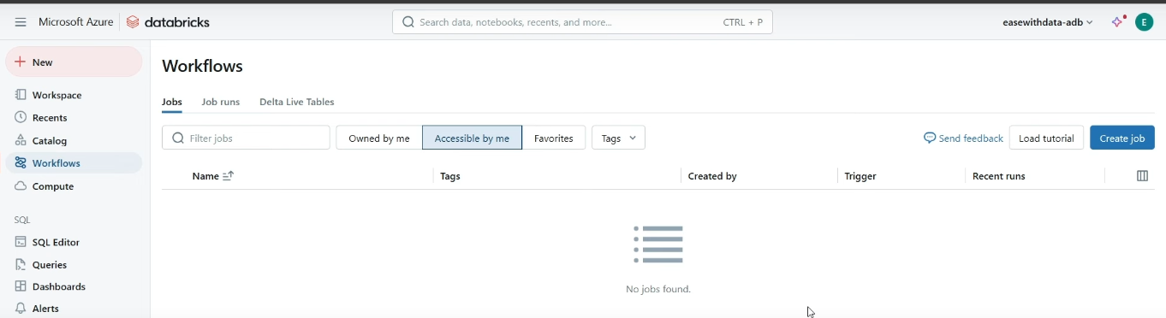**Inside the create job**:

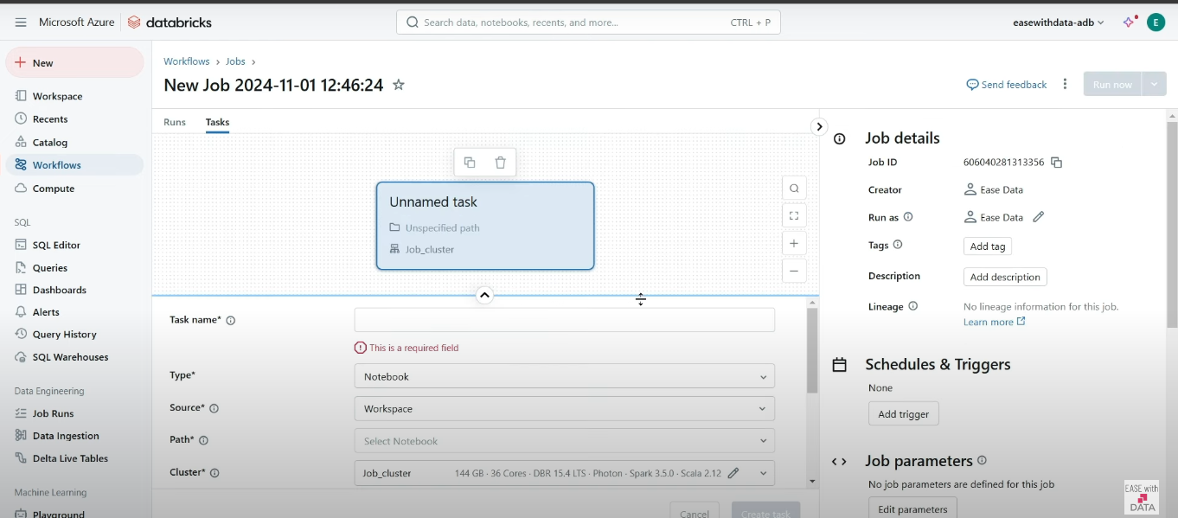

**Final workflow run page**:

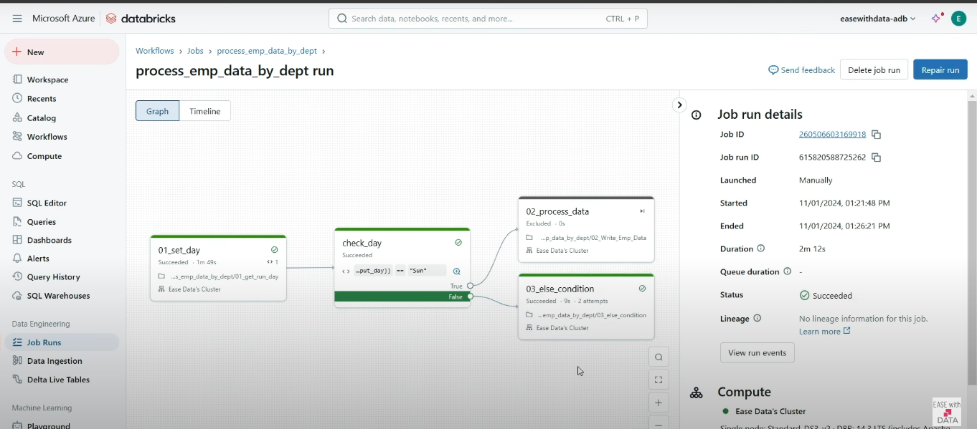

**We can see the job run page**:

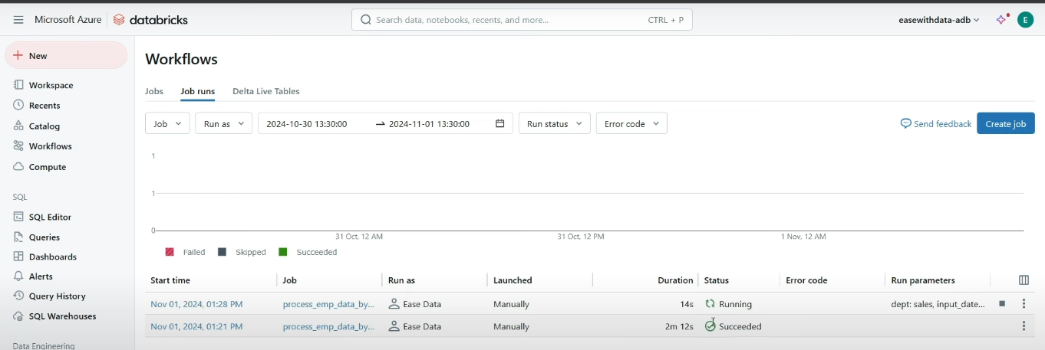

**Copy into command to load data in to delta lake.**

Loads data from a file location into a Delta table. This is a retryable and idempotent operation — Files in the source location that have already been loaded are skipped. This is true even if the files have been modified since they were loaded.

**Place holder table, with no schema.**

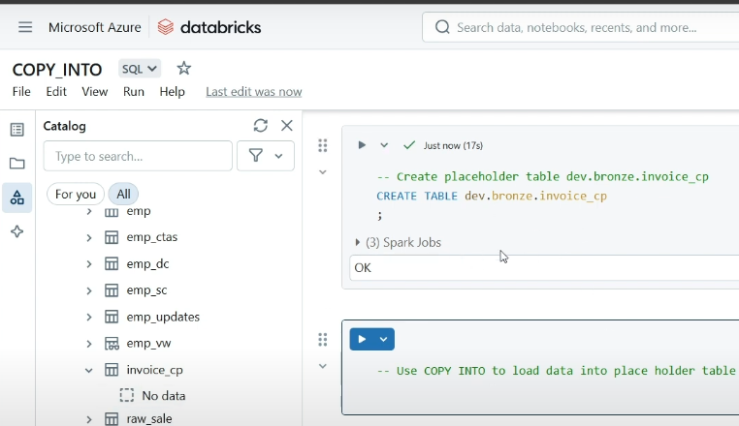

**Copy into command:**

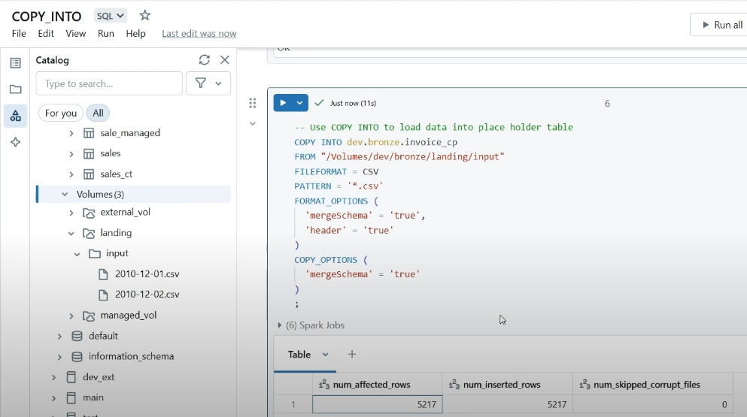In **FORMAT_OPTIONS we have mergeSchema = true**:

This is to load the files having different fields. Like if one file has 4 fields but another file having 3 fields only. So, to load both of the files using copy into command we specify mergeSchema=true.

**COPY_OPTIONS is for target table**

**Another way of copy into command, using custom select:**

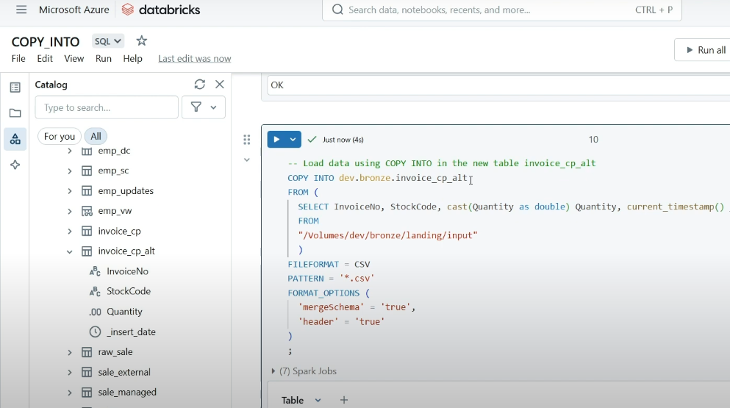

## Auto loader

Auto Loader incrementally and efficiently processes new data files as they arrive in cloud storage without any additional setup.

## **How does Auto Loader work?**

Auto Loader incrementally and efficiently processes new data files as they arrive in cloud storage. It provides a Structured Streaming source called cloudFiles. Given an input directory path on the cloud file storage, the cloudFiles source automatically processes new files as they arrive, with the option of also processing existing files in that directory. Auto Loader has support for both Python and SQL in Delta Live Tables.

You can use Auto Loader to process billions of files to migrate or backfill a table. Auto Loader scales to support near real-time ingestion of millions of files per hour.

Auto Loader can ingest JSON, CSV, XML, PARQUET, AVRO, ORC, TEXT, and BINARYFILE file formats.

## Supported Auto Loader sources

Auto Loader can load data files from the following sources:

* Amazon S3 (s3://)
* Azure Data Lake Storage Gen2 (ADLS Gen2, abfss://)
* Google Cloud Storage (GCS, gs://)
* Azure Blob Storage (wasbs://) -- deprecated
* ADLS Gen1 (adl://) -- Azure has announced the pending retirement of [Azure Data Lake Storage Gen1](https://learn.microsoft.com/azure/data-lake-store/data-lake-store-overview). Databricks recommends migrating all data from Azure Data Lake Storage Gen1 to Azure Data Lake Storage Gen2.
* Databricks File System (DBFS, dbfs:/).

**How does Auto Loader track ingestion progress?**

As files are discovered, their metadata is persisted in a scalable key-value store (RocksDB) in the checkpoint location of your Auto Loader pipeline. This key-value store ensures that data is processed exactly once.

In case of failures, Auto Loader can resume from where it left off by information stored in the checkpoint location and continue to provide exactly-once guarantees when writing data into Delta Lake. You don’t need to maintain or manage any state yourself to achieve fault tolerance or exactly-once semantics.

## **Incremental ingestion using Auto Loader with Delta Live Tables:**

Databricks recommends Auto Loader in Delta Live Tables for incremental data ingestion. Delta Live Tables extends functionality in Apache Spark Structured Streaming and allows you to write just a few lines of declarative Python or SQL to deploy a production-quality data pipeline with:

* Autoscaling compute infrastructure for cost savings
* Data quality checks with [expectations](https://docs.databricks.com/en/delta-live-tables/expectations.html)
* Automatic [schema evolution](https://docs.databricks.com/en/ingestion/cloud-object-storage/auto-loader/schema.html) handling
* Monitoring via metrics in the [event log](https://docs.databricks.com/en/delta-live-tables/observability.html" \l "event-log)

You do not need to provide a schema or checkpoint location because Delta Live Tables automatically manages these settings for your pipelines. See [Load data with Delta Live Tables](https://docs.databricks.com/en/delta-live-tables/load.html).

Databricks also recommends Auto Loader whenever you use Apache Spark Structured Streaming to ingest data from cloud object storage. APIs are available in Python and Scala.

**Auto Loader supports two file detection modes. See:**

[What is Auto Loader directory listing mode?](https://docs.databricks.com/en/ingestion/cloud-object-storage/auto-loader/directory-listing-mode.html)

[What is Auto Loader file notification mode?](https://docs.databricks.com/en/ingestion/cloud-object-storage/auto-loader/file-notification-mode.html)

Let’s load using [directory listing](https://docs.databricks.com/en/ingestion/cloud-object-storage/auto-loader/directory-listing-mode.html) mode(default one)

Step 1:

Create the volume path for the files, from where we will be loading into the delta lake tables.

Step 2:

We also need a location, where we are going to save our checkpoint.

Checkpoint: Auto loader uses checkpoint, in-order to manage incrementally processed files from cloud storage location.

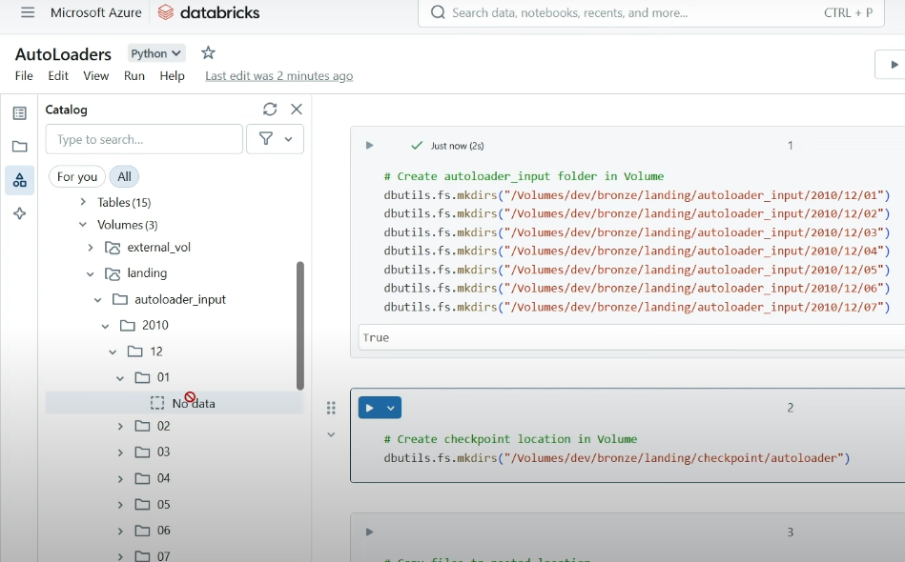__________________________________________________________________________________________

Step 3:

Copy the data into the location we created in step 1.

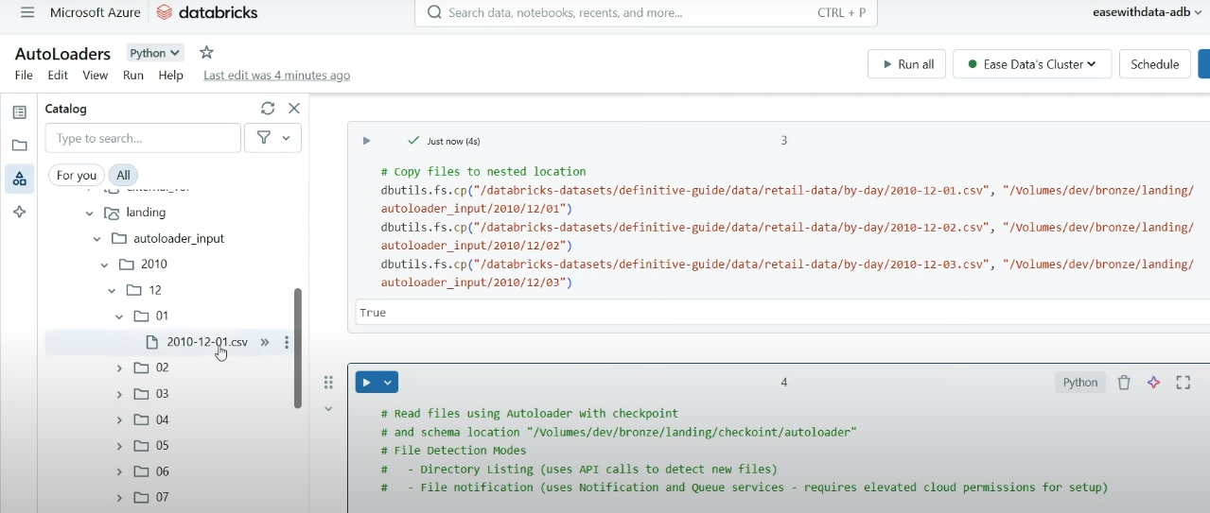

Step 4:

Load the data using auto loader:

So, below will give our data into a dataframe. Then we can write in the delta lake table.

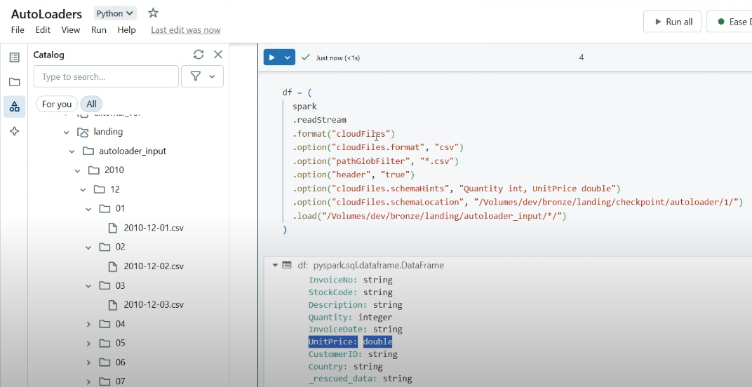

Step 5: Now load the data into delta tables:

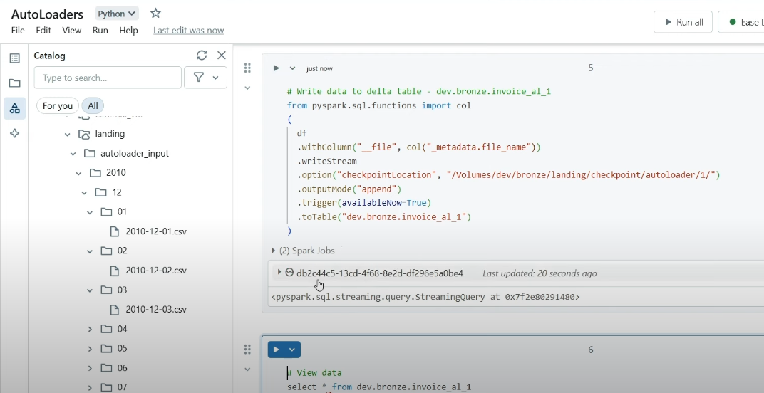d

When new fields are in some files, then use .options(“mergeSchema”, True)

**We have option – schemaEvolutionMode as rescue:**

So, whenever we have schema change, new columns that are added as a part of schema change, will be come under field _rescued_data, but default it adds new columns.

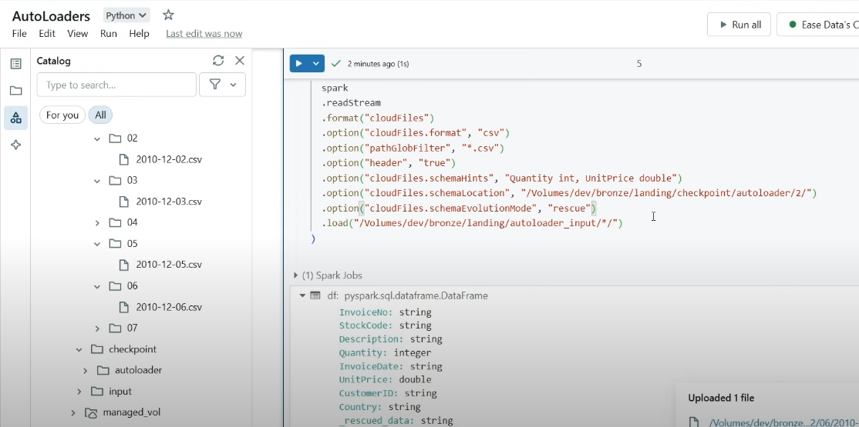

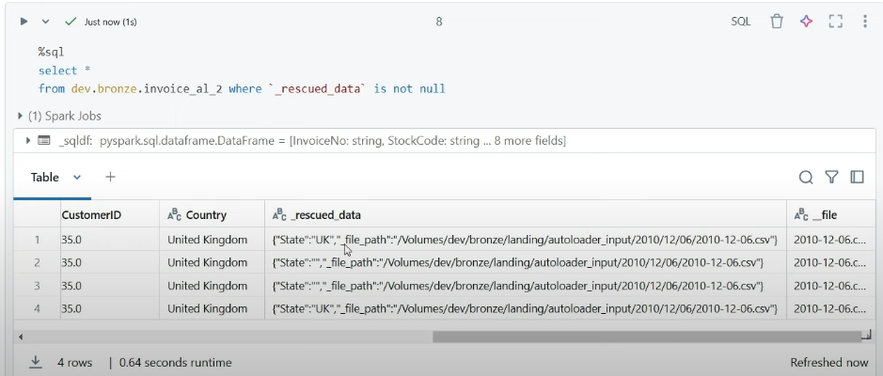

When **schemaEvolutionMode as None:**

It won’t rescue any new field, and load the data with adding new fields.

When **schemaEvolutionMode as FailOnNewColumns:**

It will fail the data load if there are new fields.

Medallion architecture:

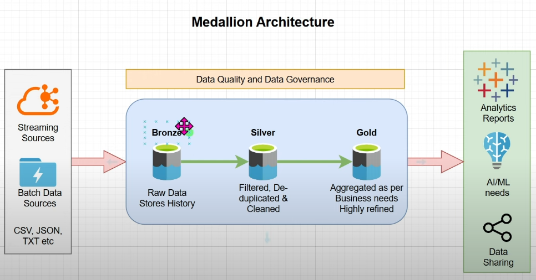

**Delta live tables:**  
Delta Live Tables (DLT) is a declarative ETL framework for the [Databricks Data Intelligence Platform](https://www.databricks.com/product/data-intelligence-platform) that helps data teams simplify [streaming](https://www.databricks.com/product/data-streaming) and batch ETL cost-effectively. Simply define the transformations to perform on your data and let DLT pipelines automatically manage task orchestration, cluster management, monitoring, data quality and error handling.

In simple explanation:

Delta live tables is a declarative ETL framework build by databricks to make ETL or data processing pipeline easier.

Declarative framework means : One only need to worry about writing transformations and not about the background working.

Declarative framework automatically manage task orchestration, cluster management, monitoring, data quality and error handling.

Note:

delta live table requires premium plan.

## **What are Delta Live Tables datasets?**

Delta Live Tables datasets are the streaming tables, materialized views, and views maintained as the results of declarative queries. The following table describes how each dataset is processed:

| **Dataset type** | **How are records processed through defined queries?** |
| --- | --- |
| Streaming table | Each record is processed exactly once. This assumes an append-only source. |
| Materialized view | Records are processed as required to return accurate results for the current data state. Materialized views should be used for data processing tasks such as transformations, aggregations, or pre-computing slow queries and frequently used computations. |
| View | Records are processed each time the view is queried. Use views for intermediate transformations and data quality checks that should not be published to public datasets. |

**Step 1:**

Let’s create a streaming table:

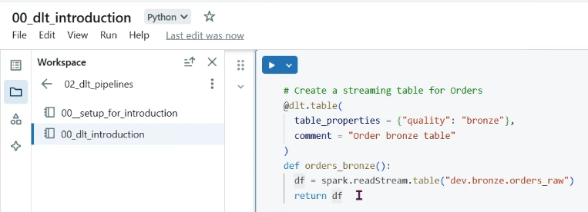Above transformation in orders_bronze function will be applied to the decorator @dlt.table. And by default name of streaming table will be name of function(orders_bronze) or manually specify in the decorator.

__________________________________________________________________________________

**Step 2**: Lets create a materialized view:

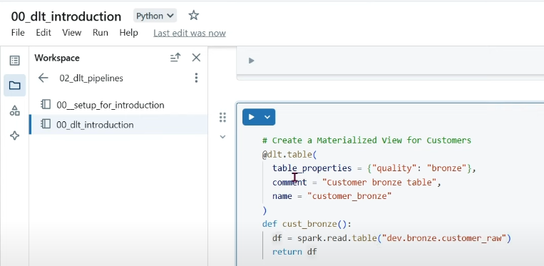

Step 3:

Joined above streaming table and materialized view using view:

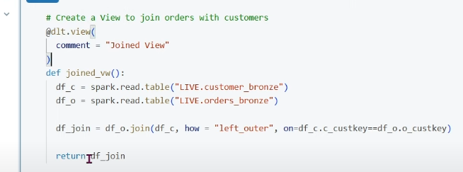

**Step 4**: Lets add one more extra column in silver zone using Materialized view:

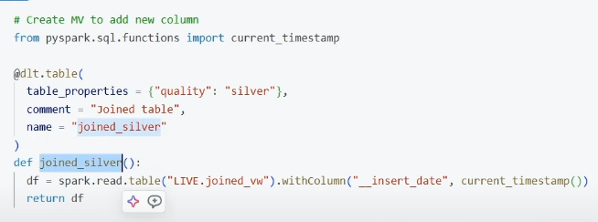**Step 5**: Lets aggregate in gold zone using Materialized view:

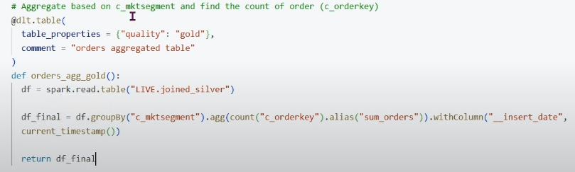

Now all steps are ready, we can proceed with the delta live table pipeline:

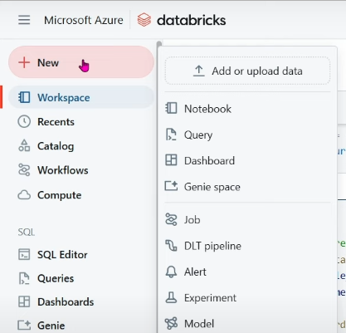xxx

and create the pipeline:

